TimeCore.
Robert Johansson
Degree Project FSU24D
2025-11-28

Table of Contents
Project idea summary 3
Application flow 3
Purpose 5
Target audience 5
Goal 5
Activity and time plan 6
Technical Breakdown 8
Time Reporting 9
External Integrations 14
Database structure 15
User stories x 5 16
Test plan 19
Tech stack 21
References 24

Project idea summary
The idea of this project comes from hearing about a problem from my friend’s company. They did their time summary in an excel document to report to Fortnox. This was not an efficient way to create their invoices. I want to create a system to automatically register the invoices to Fortnox whit a push of a button. I think many companies would benefit from a system like this to save both time and money.

Application flow
My plan for this project is to make it simple to implement to other company sites as a feature. I want to focus on the system to make it dynamic so it´s easy to change values and structure. I want a simple flow so everyone using it can understand how to use it independently at a knowledge level.

So here is a short description of what to expect on each page.

- A simple index site to describe the system with a menu
- Login page –> login or create account or restore password
- Create account page –> form to create an account
- Account page –> overview whit a menu
- Register time page –> register time, sick and vacation
  - Register time page -> a form
  - Sick leave –> a quick form
  - Vacation –> form focus for vacation registry
Overview time page –> summary, all registered timecards
  - Summary –> statistic and date range
  - Timecards –> all timecards in date range with edit
Admin page –> menu
  - Overview total page –> summary, all registered timecards
  - Statistic page –> shows the statistic on the registered data
  - Billing page
    - generate PDF –> Manage PDF component
    - create invoices -> create invoices to Fortnox

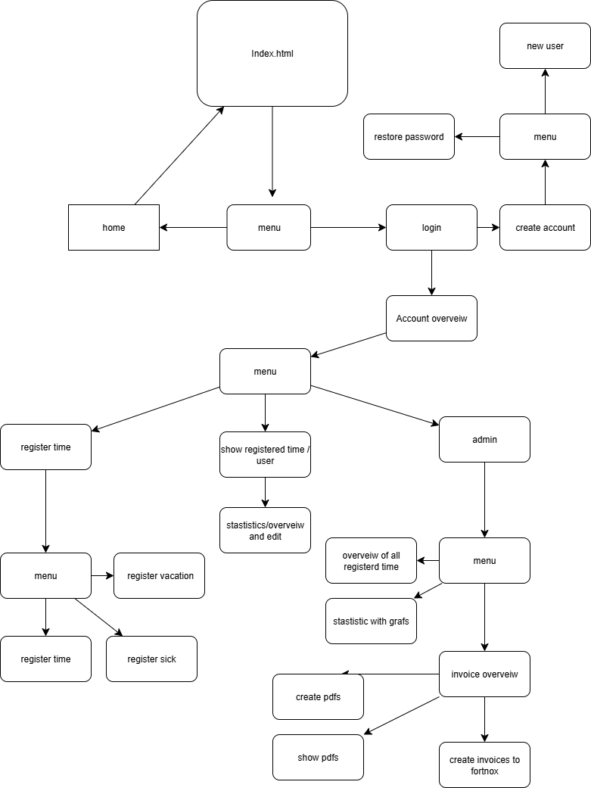

Purpose
The idea of this project comes from hearing about a problem from my friend’s company. They did their time summary in an excel document to report to Fortnox. This was not an efficient way to create their invoices. I want to create a system to automatically register the invoices to Fortnox with the push of a button. I think many companies would benefit from a system like this to save both time and money.

Target audience
My target audience is smaller companies that are using Fortnox or a similar billing system and want a simple system to register the labor for themselves and their employes. To save time for the billing process.

They are interested because of the simplification of the billing process. This will save the company both time and money, because time IS money. They will also get an overview of all statistics.

Goal
The goal of this project was to develop a fully functional system that implements the core features defined in the project planning, while being designed for long-term scalability and future growth.

It is expected to be used like this:
The user registers what they do every day/month
The admin checks the registered time and creates invoices
The admin can check statistics

Activity and time plan

Week/sprints | Objective | Comment
1-2, sprint 1 | Technical setup, authentication & core foundation | Set up development environment, implement deployment, build database schema, implement full authentication system (register/login/logout), permission middleware, basic app layout, login/create account pages, testing setup.
3-4, sprint 2 | system & statistics | Implement work/sick/vacation registration (backend + UI. build user and admin time overviews, add statistics and charts, apply permissions, add additional tests.
5-6, sprint 3 | Billing, PDFs, Fortnox integration & real-time features | Implement PDF generation, admin PDF management, invoice mapping, Fortnox API integration, invoice creation flow, admin invoice overview, Real-time behavior in the system is achieved through backend-driven updates and data refetching.  WebSocket-based communication is not required for the scope of this project, full responsiveness, accessibility fixes, end-to-end testing, final polish.

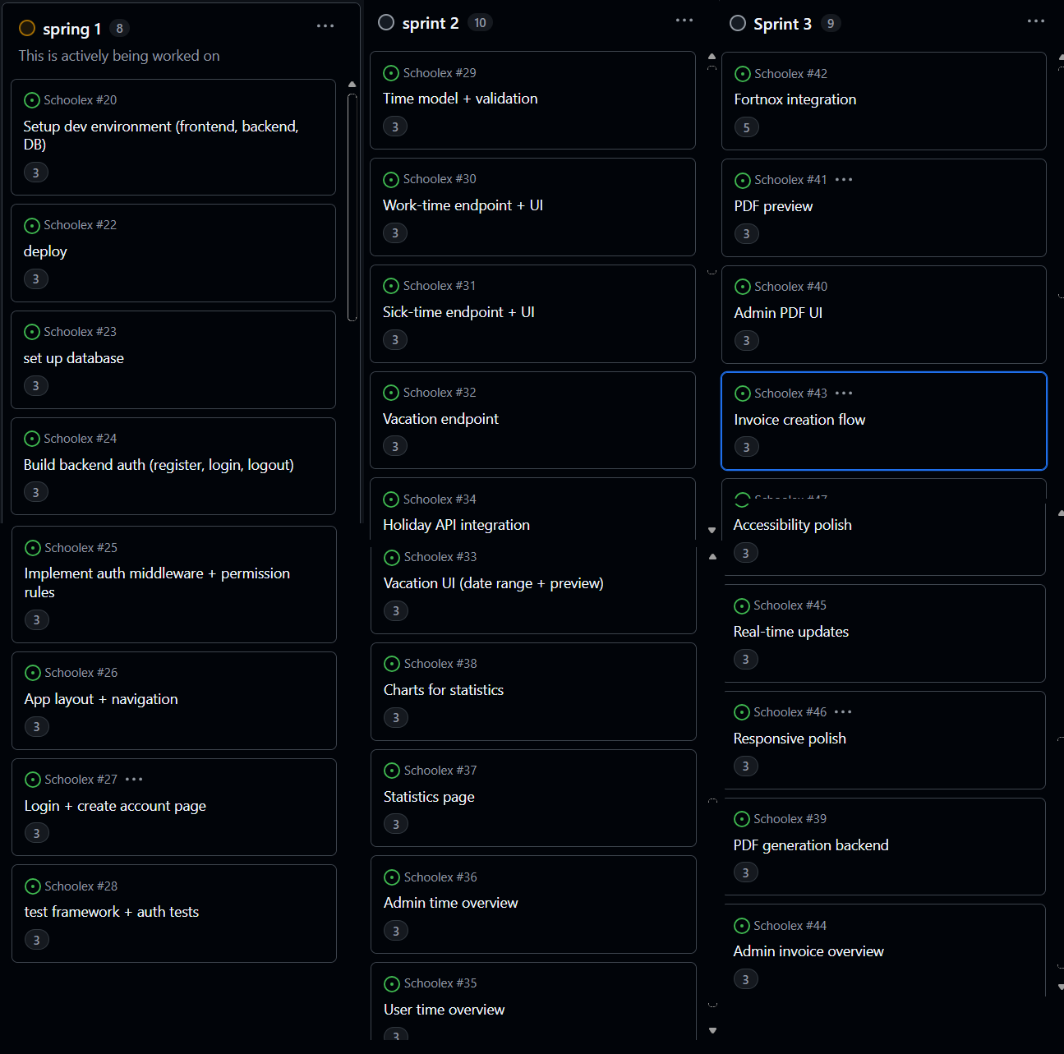

Technical Breakdown

This section provides a high-level technical overview of the system architecture and core functionality. It explains how the main features of the system work together from a frontend and backend perspective, without going into low-level implementation details. Detailed technical descriptions of the frontend architecture, backend API design, authentication model, routing, and database structure are documented in separate technical documents for the frontend and backend.

These documents are referenced where relevant throughout this report. For a visual overview of the application structure and navigation, see the sitemap on page 4.

Authentication & Account Management
This will be the security of the system the system will use a custom email + password authentication system. Authentication secures all user-specific and admin-specific routes.

Frontend
The login flow will be implemented in a dedicated /login page using a controlled form
A register page will allow users to create an account.
On successful login, the backend issues a JWT access token that is stored in an Http Only cookie.
The frontend never stores or accesses the token directly, and all authentication and authorization
decisions are handled by the backend. Protected areas will use wrappers such as:
RequireAuth – allows access only if a token is present.
RequireAdmin – checks user role from the token.
After login, the user is redirected to /account, which contains the main menu and subpages for time registration, overview, billing, etc.

Backend
A auth subsystem will be created under /api/auth, including:
POST /api/auth/register – create account
POST /api/auth/login – validate credentials + return JWT
GET /api/auth/me – return logged-in user info
POST /api/auth/restore – start password reset process

The backend uses
bcrypt for password hashing
JWT for session management
Express middleware to verify tokens on all protected routes

Database
The user table will look like this:
Column | Description
id | primary key
name | user full name
Email | unique identifier
password_hash | hashed password
avatar_url | User image
role | "user" or "admin"
tenant_id | separates companies
created_at | timestamp
updated_at | timestamp
is_active | If user is active
level_id | payment levels
deleted_at | timestamp

This authentication layer becomes the security foundation for all other system functionality.

Time Reporting
Time reporting is one of the core features of the system. It includes registering regular work hours, sick leave and vacation.

Frontend
Time reporting pages are located under /account. Components include:
TimeRegisterpage that includes:
Forms for:
  - Work hours(register time and articles)
  - Sick leave (simple, quick form)
  - Vacation (uses a start/end date system and validates against holidays)

All forms send API requests to the backend via POST /api/timereport.

Backend
POST /api/timereport (Creating new time entries)
GET /api/timereport (Using this to get the registerd time)
PUT /api/time-reports/:id (For updating the time entrie)
DELETE /api/time-reports/:id (Delete)

Each request uses the authenticated user (req.user) to ensure:
Users only see their own records
Admins can access all time reports for their tenant

Database
Column | Description
id | Primary key (auto-increment)
user | ID of the user who registered the time
customer_id | Customer associated with the time entry
note | Optional note or description
work_labor | Description of performed work
category | Type of entry (work, sick leave, vacation)
modified | Last modification date
date | The date the work was performed
hours | Number of hours
billable | Whether the hours are billable
project_id | Optional project identifier
created_date | Timestamp
billed | If the timecard is billed true/false
invoice_number | The number on the invoice

Time Overview & Statistics
This part allows users and admins to inspect all recorded time, filter by dates, view statistics, and perform administrative oversight.

Frontend
The main components are:
TimeOverveiwLayout
TimeOverveiwpage
Summary tabs showing:
  - Total hours
  - Sick and vacation summaries
  - Graphs and visual statistics
  - Detailed list of timecards with edit/delete support

Filtering uses date pickers and queries the backend dynamically.

Backend
The backend exposes endpoints for aggregated statistics:
GET /api/timereports/summary
GET /api/timereports/statistics
GET /api/admin/timereports (admin-only)

The backend performs database-level aggregation:
SUM(hours)
COUNT entries per category
Filtering by user or by tenant

This ensures consistency between all statistics views.

Billing & PDF Generation
Billing is an advanced subsystem allowing admins to generate invoice-ready PDF summaries of time reports.

Frontend
Admin pages for billing will include:
BillingOverviewList
BillingOverviewDetails
PDF will have popup components like (SendPdfDialog, PDF result modals)
Tools to:
  - Filter customers
  - Select time ranges
  - Generate PDFs
  - Send PDFs via email
  - Preview invoice information

Selecting entries triggers a mass operation such as Generate PDFs or Proceed to Invoicing.

Backend
Billing logic will be handled in controllers such as:
billing.controller.js
worklogPdf.controller.js

Backend functionality includes:
Fetching time reports for selected period/customer
Applying pricing rules like price levels
Creating invoice data structures
Generating PDF files
Storing PDF binary in the database
Returning it for download or email
Logging operations

Main routes include:
- POST /api/billing/generate
- GET /api/pdf/:id
- POST /api/pdf/send
- POST /api/invoices/create

Database
PDFs are stored in a table such as:
Column | Description
id | Primary key (auto-increment)
invoice_id | Related invoice (unique if one PDF per invoice)
customer_id | The customer this PDF belongs to
invoice_number | Invoice number stored inside the PDF metadata (optional)
period_from | Start date of the invoiced period
period_to | End date of the invoiced period
file_name | Original file name of the PDF
mime | File MIME type (always application/pdf)
size_bytes | File size in bytes
sha256_hex | SHA-256 hash of the PDF for integrity verification
data | The actual PDF binary data (stored as longblob)
fortnox_archive_file_id | ID from Fortnox if the PDF has been uploaded there
fortnox_connected_at | Timestamp when the file was synced with Fortnox
created_at | Timestamp when the record was created
updated_at | Timestamp automatically updated on modification

This allows:
- Immediate download
- Sending through email
- Later reuse when invoices are synced to Fortnox

Admin Functionality
Admin pages allow full control over:
- All time reports from all users
- Billing overview
- PDF management
- Statistics
- Customer relationships
- Invoice generation

Frontend
Admin routes are accessible under /admin/* and will be wrapped in RequireAdmin.

Backend
Admin-specific controllers ensure:
Role validation (req.user.role === "admin")
Data filtering by tenant
Access to all users’ time reports

Admin routes include:
- /api/admin/timereports
- /api/admin/overview
- /api/admin/statistics
- /api/admin/invoices

Database Model Overview
The system uses a tenant-separated data model:

Key Tables
- users
- time_report
- customer
- worklog_pdf
- user_pricing_levels

Key design principles
All business data links back to tenant_id.
No cross-tenant access.
Admins manage all data inside their tenant.
Users only manage their own time reports.

Backend Architecture
The backend is built using:
Node.js
Express.js
Middleware-based architecture
Controllers grouped by feature
Central JWT authentication middleware
Error handling layer
Database access using MySQL
Modular routing structure:
  - /api/auth
  - /api/timereports
  - /api/admin
  - /api/billing
  - /api/invoices
  - /api/pdf

External Integrations

Fortnox
Admin can export invoices to Fortnox.
The backend:
Uses Fortnox API keys
Creates invoices using Fortnox schema
Sends customer, item, and invoice data via REST API

Email sending (SMTP)
Used to send PDFs to customers. Backend uses:
nodemailer
SMTP settings from config
Templates for email bodies

PDF generation
Backend generates PDFs from prepared invoice/time report summaries.

Database structure
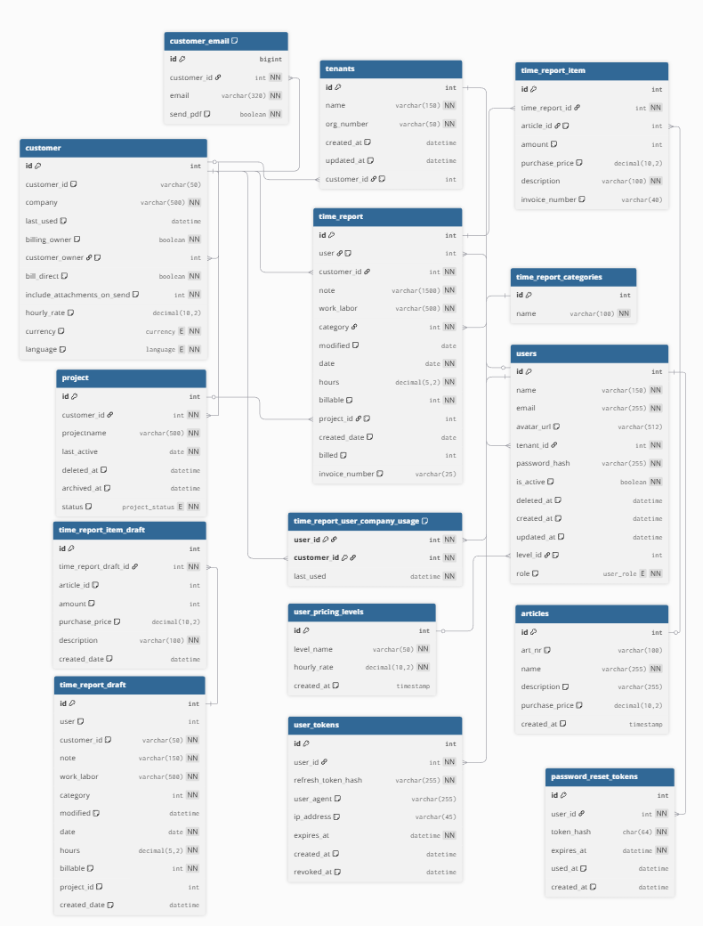

Figure X. Logical database model for the TimeCore system, illustrating the main entities and relationships
that support authentication, tenant isolation, time reporting, administration, and billing workflows.

User stories x 5

Persona 1 – The Employee / Consultant
Name: Emma Larsson, 28
Profession: Frontend Consultant
Technical Skill: High
Uses the system for: Daily time reporting
Why: To register her working hours, sick leave, and vacation days
Description:
Emma works as a consultant across different client projects. She uses the system every day to register her hours and occasionally review her weekly overview. Speed and simplicity are important for her workflow.
User Journey:
Logs in
Navigates to Register Time
Enters hours, customer, project, and optional notes
Saves the entry
Views the updated overview in Time Overview

Persona 2 – The Administrator / Billing Responsible
Name: Sara Nilsson, 39
Profession: Administrative Assistant / Billing Coordinator
Technical Skill: Medium
Uses the system for: Invoice creation, PDF generation, and Fortnox synchronization
Why: To ensure all customer hours are billed correctly and on time. Description:
Sara handles billing and needs reliable, structured access to all customer reports. She generates invoice PDFs, sends them to customers, and synchronizes invoices with Fortnox.
User Journey:
Logs in
Goes to Admin → Billing
Selects customer and time period
Generates invoice PDF
Reviews the billing history

Persona 3 – The Company Owner
Name: Daniel Bergström, 47
Profession: CEO, Consulting Agency
Technical Skill: Low–Medium
Uses the system for: High-level statistics and financial insights
Why: To understand company performance and make strategic decisions. Description:
Daniel uses the system occasionally to get a clear picture of how the company is performing. He focuses on billable hours, revenue potential, and overall staff productivity.
User Journey:
Logs in
Opens Admin → Statistics
Reviews graphs showing hours, utilization, sickness, and revenue trends
Goes to Billing to check invoice status
Verifies completed PDF invoices and Fortnox connections

Persona 4 – The Internal Developer
Name: Mikael Holm, 32
Profession: Fullstack Developer
Technical Skill: Very High
Uses the system for: Testing features, validating API endpoints, and improving system functionality
Why: He is responsible for system quality, performance, and new feature development.
Description:
Mikael maintains the platform internally. He uses the system both as a user and as a developer. He tests the entire flow from time registration to billing and invoices.
User Journey:

Logs in
Tests time reporting, billing, and admin features
Uses development tools to inspect API responses
Validates that changes in the backend behave correctly in the UI
Reviews logs and confirms system stability before deployment

Persona 5 – The Time Reporting Supervisor
Name: Johan Ekström, 41
Profession: Operations Coordinator / Reporting Supervisor
Technical Skill: Low
Uses the system for: Ensuring all consultants have registered their hours correctly
Why: To verify completeness, accuracy, and consistency in time reporting before billing and payroll.
Description:
Johan is responsible for making sure that every consultant has submitted their hours for the week. He uses the system to check missing hours, look for irregularities, and ensure that sick leave and vacation are correctly logged. His main focus is operational accuracy rather than financial billing.
User Journey:
Logs in
Opens Statistics
Filters by week to see total hours per user
Checks deviations, missing entries, or unexpected zero days
Reviews sick and vacation summaries

Test plan
This project will be tested continuously throughout the development process rather than only at the end. Each feature will be implemented, validated, and reviewed in small, manageable stages to ensure stability and correctness before moving forward.
The testing strategy includes a combination of manual feature testing, API testing, integration testing, and light user testing with real stakeholders. The goal is to guarantee that all core functionality—such as time reporting, statistics, billing, and PDF generation—works reliably in realistic scenarios.

1. Continuous Feature-by-Feature Testing
Each time a major component or page is built, it will be tested individually before proceeding. Examples include:
Testing the login flow after the new custom authentication system is implemented.
Testing the Register Time page: adding hours, sick leave, and vacation entries.
Testing Statistics filters and overview summaries.
Testing Admin Billing by generating PDF invoices for a sample customer.
Testing Fortnox integration with mock or test customers.
This approach ensures early detection of bugs and prevents major issues from building up later in the project.

2. Backend API Testing
Every backend endpoint will be tested using tools such as:
Postman
Example API tests include:
Creating, updating, and deleting time reports
Fetching statistics with different date ranges
Generating PDFs and validating response structure
Sending test emails
Verifying invoice creation and Fortnox connection workflows
This ensures that the frontend and backend stay reliable and consistent.

3. Browser Manual Testing
The system will be tested in multiple browsers:
Chrome
Edge
Firefox
Focus areas:
Navigation flow
Form validation
Responsive layout
Error handling and feedback messages
This ensures a stable user experience across platforms.

4. User Acceptance Testing (UAT)
Near the end of the project, informal testing will be done with real users representing different personas:
A consultant registering time
An administrator generating invoices
A company owner checking statistics
These users will be asked to complete specific tasks, for example:
Register work hours for a specific date
- View statistics for the past month
- Generate a PDF invoice for a given customer
- Send an invoice to themselves by email

Their feedback will be used to refine usability and identify issues that developers might overlook.

5. Optional Automated Tests
If time permits, automated tests may be added for:
Reusable JavaScript/TypeScript utility functions
Critical backend validation logic
PDF generation helpers
This is optional but beneficial for long-term maintainability.

6. Final Regression Testing
Before submission, all major flows will be tested end-to-end:
Login → Register Time → Statistics
Login → Admin → Billing → Generate PDF → Send Email
Time reporting → Invoice creation → Fortnox sync (mock)
This ensures that new changes have not broken existing functionality.

Tech stack
I chose this tech stack because it allows for fast development, excellent component reusability, and a clean separation between frontend and backend. React with Vite provides a modern, high-performance development experience, while Node.js with Express offers flexibility and scalability on the server side. MySQL was selected for its reliability, structured data model, and suitability for a multi-tenant architecture.

Frontend: React + Vite
Framework: React (TypeScript)
Build Tool: Vite for instant dev server, fast HMR, and optimized builds
Styling:
  - Tailwind CSS
  - shadcn/ui for consistent UI components
  - Framer Motion for animations
Routing: React Router
State/Data Handling: Context API, custom hooks
Reason for choice:
  - Component-based architecture
  - Large ecosystem
  - Fast development workflow with Vite
  - Easy integration with UI libraries and reusable design patterns

Backend: Node.js + Express
Framework: Express.js
Language: JavaScript (with structured folder layout)
API Structure: REST API with controllers, services, and middleware
Auth: Custom JWT authentication
Validation: Express middleware + manual validation
Email: Nodemailer for PDF invoice delivery
External Integrations: Fortnox API (for invoices)
Reason for choice:
  - Lightweight and flexible
  - Easy to integrate with MySQL
  - Excellent for building a modular API-driven backend

Database: MySQL
Model: Relational SQL database
Schema:
  - Users
  - Time Reports
  - PDF/Invoice Storage
  - Customers
  - Levels / hourly pricing
  - Invoices
Chosen because:
  - Well-suited for structured reporting data
  - Reliable transactions
  - Easy to query for statistics, billing summaries, and aggregations
  - Works well in multi-tenant setups

Testing Approach
Continuous manual feature-by-feature testing
API testing using Postman
End-to-end flow testing before delivery
User testing with selected personas

Deployment Tools & Pipeline
Hosting:
  - Dynamicbranch hosting
Continuous Integration:
  - GitHub Actions
Build:
  - Vite build for frontend
  - Node-run backend deployed as service

Development Configuration
Linting & Formatting:
  - ESLint
  - Prettier
Build Tools:
  - Vite for frontend bundling
  - Node scripts for backend
Environment Management:
  - .env files for local dev
  - Secure environment variables for production (Fortnox API keys, SMTP credentials, JWT secrets)

Graphics & UI Resources
Icons: Lucide Icons (via shadcn/ui)
UI Library: shadcn/ui for consistent, professional components
Design System:
  - Tailwind for utility-first styling
  - Custom themes with CSS variables
  - Motion effects using Framer Motion

Accessibility Considerations
Semantic HTML through React components
Proper labeling for all form elements
High-contrast mode through dark/light theme
Testing website with lighthouse

Documentation
Code Documentation:
  - Commented controllers, hooks, and services
  - Readable file and folder structure
Project Documentation:
  - Technical breakdown (this document)
  - User flows
  - ER diagrams and database documentation
User Manuals:
  - Short description for how to register time, generate invoices, and use admin tools

References
Below are the main references and sources of inspiration I plan to use throughout the project. These include technical documentation, design inspiration, and examples of existing systems that influence the structure and functionality of my solution.

Technical Documentation
React documentation – https://react.dev
Vite documentation – https://vitejs.dev
Express.js documentation – https://expressjs.com
MySQL documentation – https://dev.mysql.com/doc/
JWT specification – https://jwt.io
Nodemailer documentation – https://nodemailer.com
Fortnox API documentation – https://developer.fortnox.se

UI / Design Inspiration
shadcn/ui component library
Tailwind CSS documentation – https://tailwindcss.com
Lucide Icons – https://lucide.dev

